Sputtered CdS on different buffer layers

This report contains device results divided into two sets;
- CdS was deposited at 120nm thickness (may be slightly thinner for higher temperatures due to re-evaporation from the substrate) at three different substrate temperatures; room temperature, 200°C and 350°C.
- CdS was deposited at 350°C at three different thicknesses; 120nm, 240nm and 360nm

For each temperature four substrates were used; TEC15, TEC15+100nm ZnO, TEC15 + 100nm CVD SnO₂ and TEC15 + 100nm Sputtered SnO₂. For each of these combinations CdTe was deposited in the same manner by close space sublimation (CSS), 6μm thick @510°C substrate temperature. All subsequent processing steps were identical, with the exception of the CdCl₂ annealing time , which was optimized for each device plate. Each 5x5cm CdTe plate was broken into four 2.5x2.5cm quarters and four different annealing times were used. Nine 5x5mm devices were deposited on each quarter, although a significant fraction did not work due to CdTe pinholes around the device edges. Each set produced 48 (2.5x2.5cm) device plates and 432 contacts, for the purposes of easy analysis only the devices using the most commonly optimal CdCl₂ treatment (20min @420C) are given.

Section 1: Performance vs CdS deposition temperature
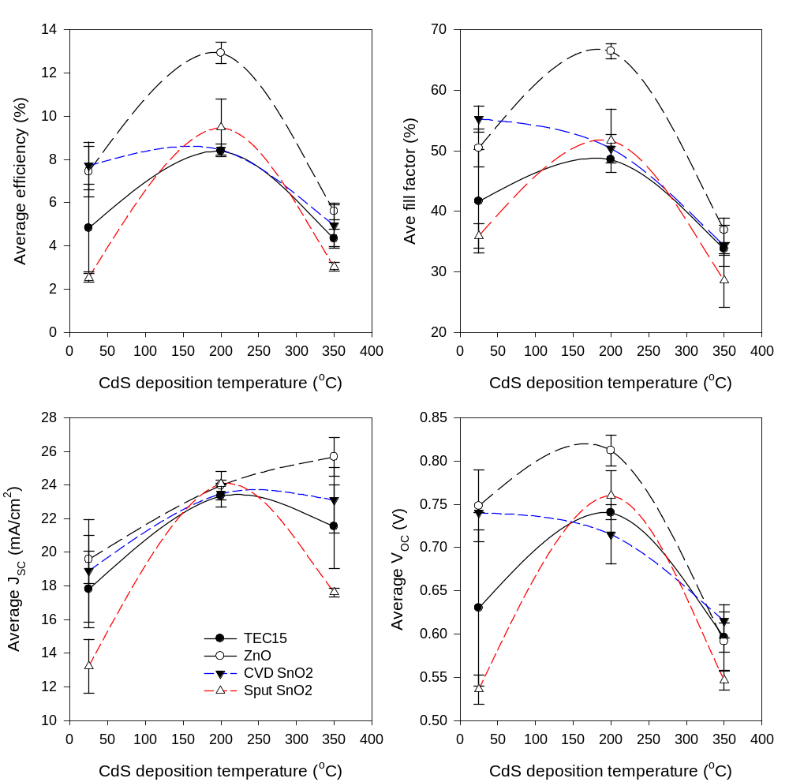
Fig 1: Device parameters vs deposition temperature. CdS is 120nm thick.

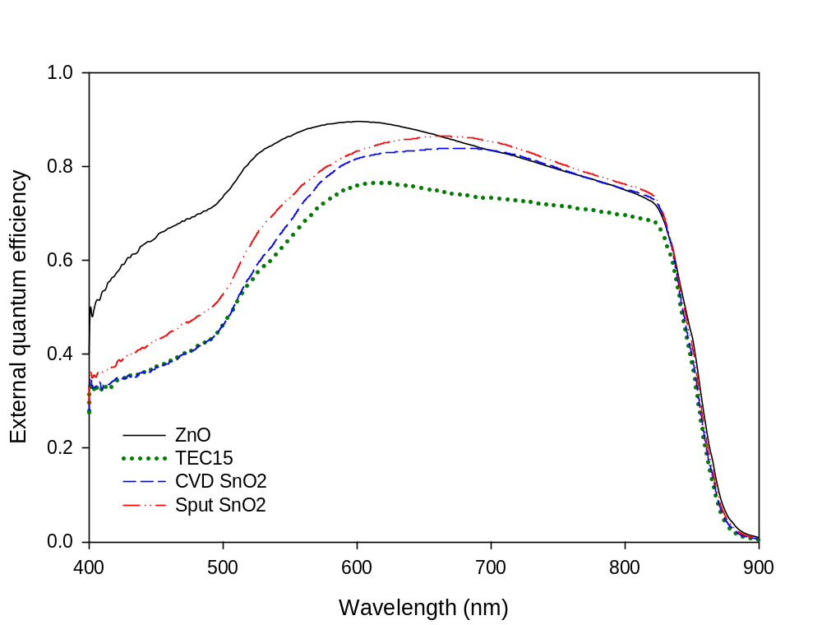
Fig 2: EQE curves of best contacts for devices based on CdS, 120nm thick deposited at 200C

Comments:
- ZnO is generally the best performing buffer layer, although to what extent this is true depends on the CdS deposition. As previous work has suggested the performance gains come principally from the fill factor although there is an improvement in V_{oc}. The J_{SC} appears to be unaffected by the choice of buffer, with all devices showing <1mA/cm² variation for CdS deposited at 200°C.
- EQE results in Fig.2 show the majority of the performance gain for the ZnO device occurs in the short wavelength region. This may imply an enhanced level of intermixing between the CdS and CdTe layers or a reduction in the defect concentration at the interface.
- It is worth noting that the level of performance variation between buffers is affected by the CdS deposition temperature. For room temperature CdS, CVD SnO₂ and ZnO buffers give almost identical performance, while at 200°C the CVD SnO₂ is the poorest performing device and the ZnO gives and exceptionally good device (see below). This implies that the buffer/CdS interface may be key in determining the device performance and that for each buffer.
- The combination of CdS deposited at 200°C and a ZnO buffer layer has given the best device results achieved so far at Durham. After further front contacting the device included in the above data had a best efficiency of η = 16.51%, FF = 73.41%, J_{SC} = 26.78mA/cm² and V_{OC} =0.84V. Repeated growth of this device gave a 1cm² device with η = 13.60% , FF = 63.15%, J_{SC} = 26.23mA/cm² and V_{OC} = 0.82V.

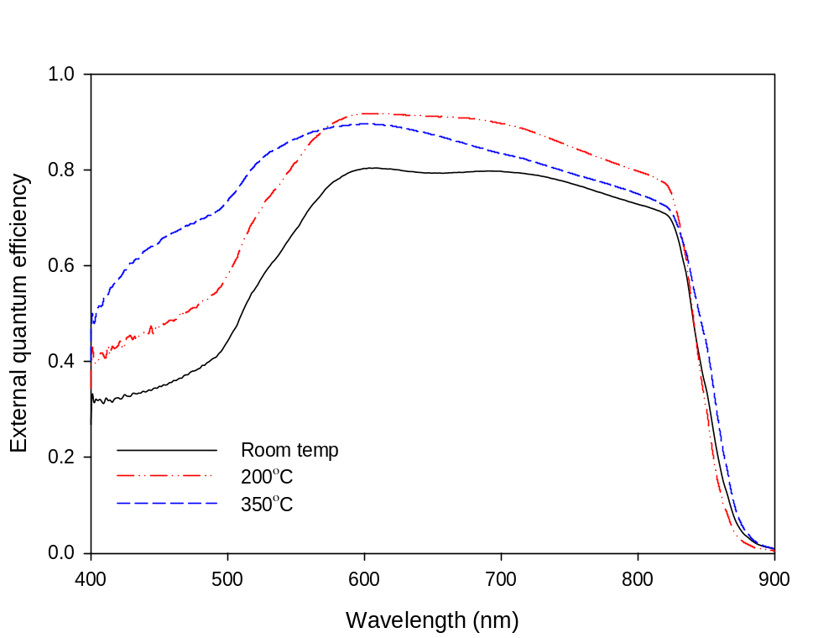
Fig 3: ZnO buffer devices for CdS, 120nm thick, deposited at different substrate temperatures

Section 2: Performance vs CdS thickness @350C
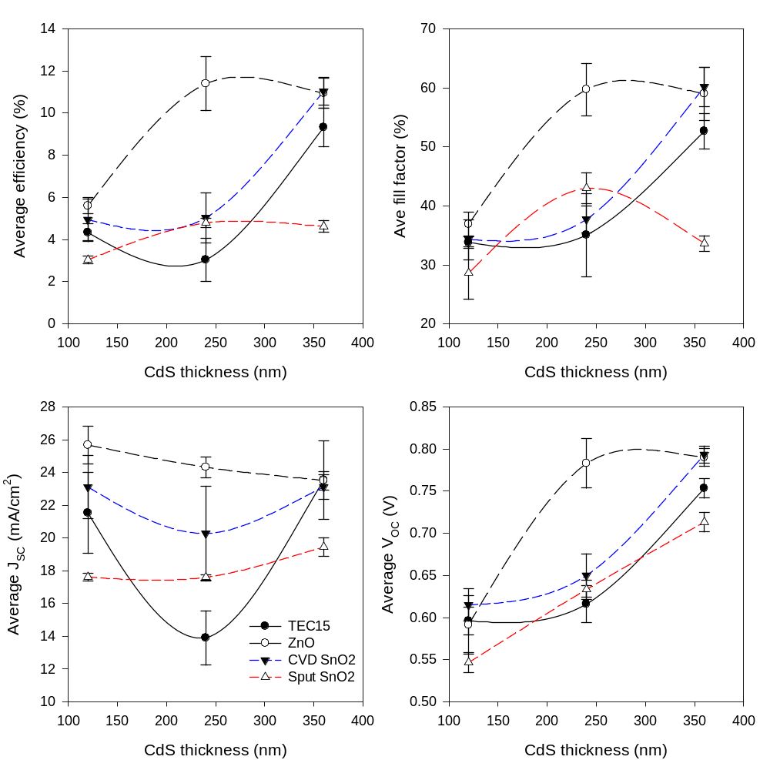
Fig 4: Device parameters vs CdS thickness. CdS deposited at 350°C.

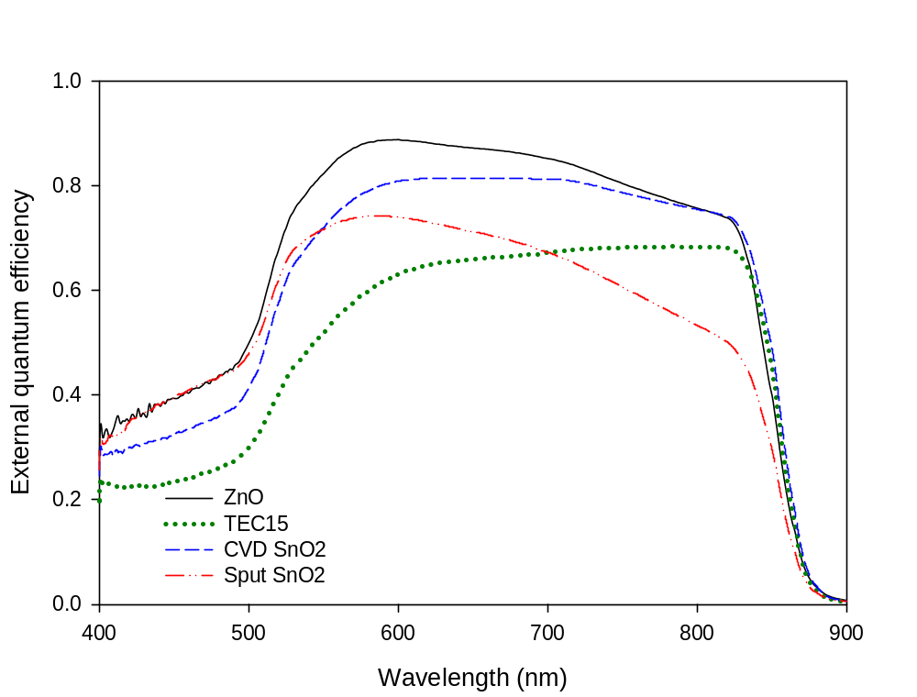 Fig 5: EQE CdS 240nm @350C
Comments:
- As before ZnO provides the stand out device result.
- The generally poor performance of devices with 120nm thickness is likely due to the grain size of CdS being larger than ideal, resulting in pinholes in the CdS film at low thickness. This was supported by the J-V curves which indicated shunting.
- This data provides good evidence that ZnO allows the CdS to be thinned to a greater extent than the SnO₂ buffers or simply TEC15. For thicker films, i.e. 360nm, there is little difference between the ZnO, TEC15 and CVD SnO₂. However, as the thickness is reduced to 240nm the ZnO maintains the same level of performance while the other buffers show significant losses. Although this 240nm point to encounter such significant losses is somewhat higher than may have been anticipated, this can again be ascribed to the CdS quality. For smaller grained CdS this divergence of the buffer performances may occur at a smaller thickness.
- Here, the V_{OC} shows comparable losses the FF due to the decreased CdS thickness.

Conclusions
Overall ZnO still appears to be the best buffer layer and has given the highest device results obtained thus far at Durham. CVD SnO₂ is capable of performing as a good buffer layer, but doesn’t appear to produce high performance devices as often as ZnO. The results in section 2 showing the added CdS thickness reduction the ZnO allows is also significant. A key conclusion I would draw from this work is that there is a perhaps a misconception in the way buffer layers are commonly discussed in the literature. It is the standard practice to tie the buffers to the TCO layer (e.g. high ρ/low ρ stack is how they are commonly referred to) and to place the emphasis on finding the best combination of the two, the NREL reports Neil distributed are a prime example of this. I think the results reported here demonstrate that a far more sensible way to view buffers would be as an addition to the CdS layer, rather than to the TCO layer. Although they may be similar materials, in terms of the function they perform within the device buffers are far closer in nature to the CdS layer than the TCO, a simple proof of this being that a working device can be made on the ZnO buffer in the absence of CdS (the same would not be true if the TCO were removed). Treating the buffer/CdS stack as a pair it should follow that for different buffer types the CdS partner that it is suited to may change and also that to assume a single CdS type is universally suitable (as is often the case) may be incorrect. In the case of ZnO, it appears there is a near optimal pairing for CdS deposited at 200°C which has yielded very good device results. However, if the case of CVD SnO₂ slightly better results were obtained for room temperature deposited CdS. To assess the true worth of a buffer layer it may therefore be necessary to establish it’s performance in conjunction with a range of CdS types, rather than a range of TCO types, as is commonly reported.

Appendix: Transmission vs temperature by buffer type

- TEC15

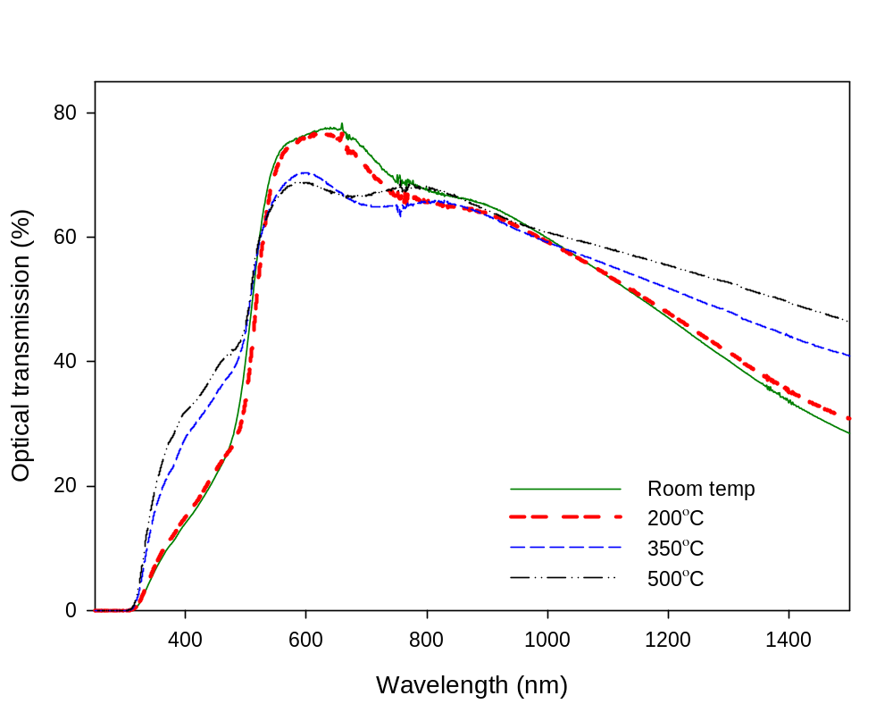
Buffer layer | Ave transmission (250-1000nm range)
Room temp | 49.59%
200°C | 48.38%
350°C | 49.52%
500°C | 50.94%
Table 1: Average optical transmission values for TEC15/CdS stacks at different deposition temps

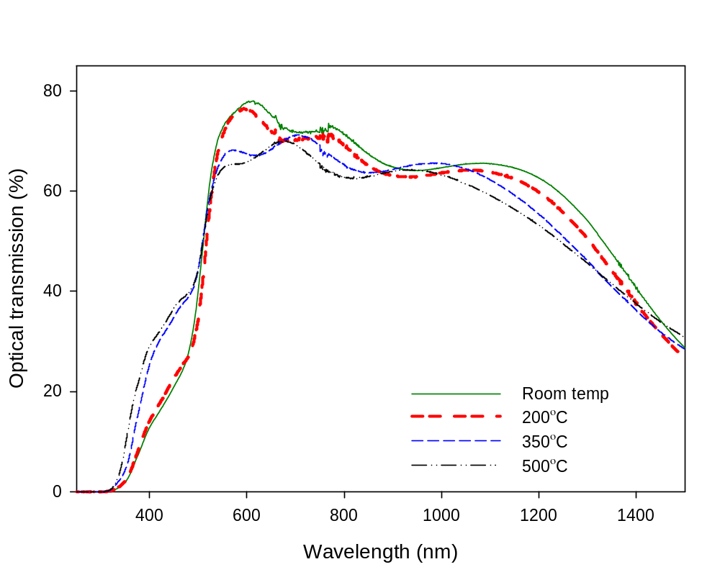
- ZnO

Buffer layer | Ave transmission (250-1000nm range)
Room temp | 49.68%
200°C | 48.44%
350°C | 49.55%
500°C | 49.25%
Table 2: Average optical transmission values for TEC15/ZnO/CdS stacks at different deposition temps.

- CVD SnO₂

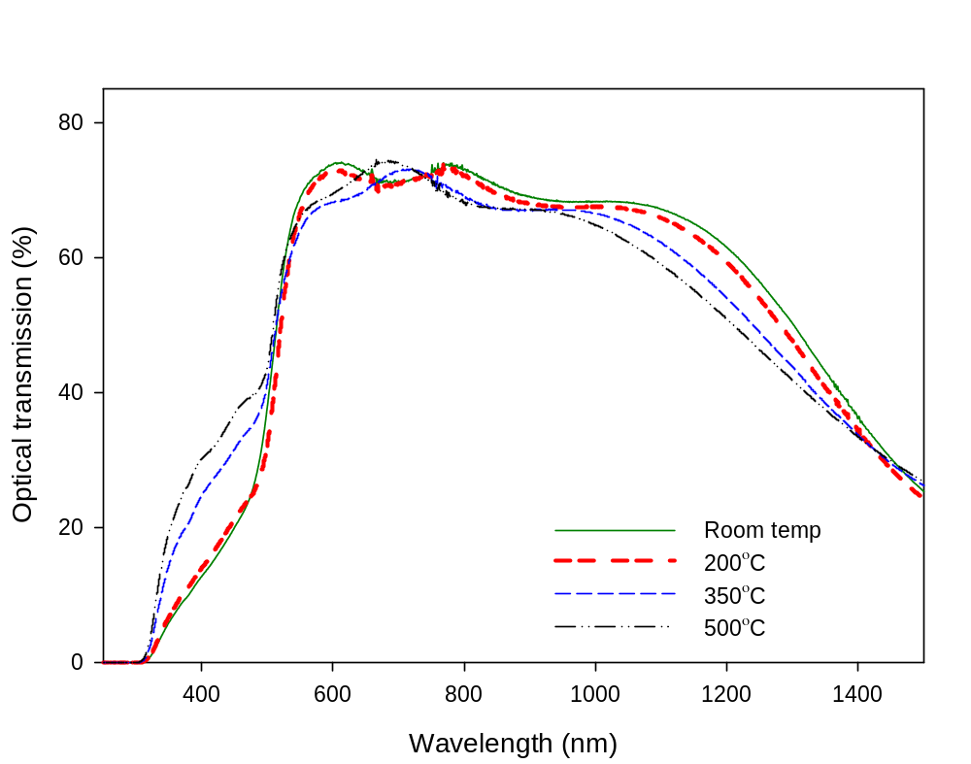

Buffer layer | Ave transmission (250-1000nm range)
Room temp | 50.02%
200°C | 49.30%
350°C | 50.80%
500°C | 52.33%
Table 3: Average optical transmission values for TEC15/CVD SnO₂/CdS stacks at different deposition temps.

- Sput SnO₂
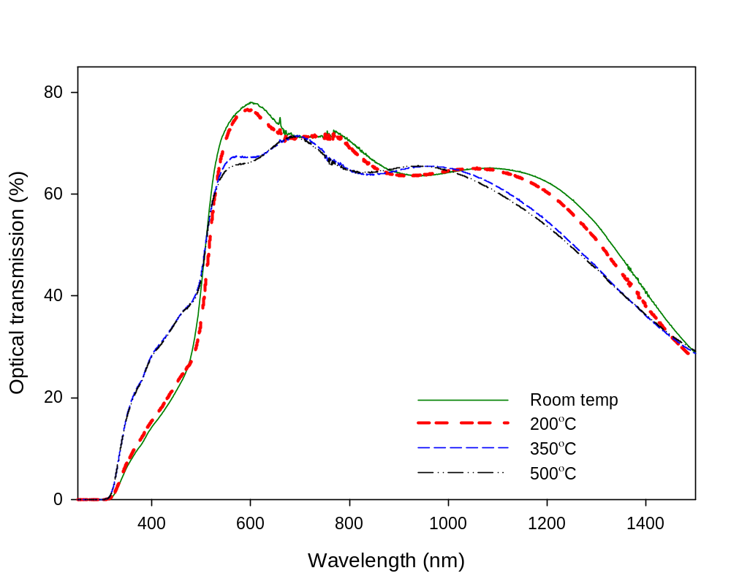

Buffer layer | Ave transmission (250-1000nm range)
Room temp | 49.86%
200°C | 49.14%
350°C | 50.45%
500°C | 50.25%
Table 4: Average optical transmission values for TEC15/Sput SnO₂/CdS stacks at different deposition temps.

Comments:
- There is not a significant amount of variation in transmission due to the different buffer types. Total range of variation is <3%.
- CdS deposited at 200°C has the lowest transmission value but gives best device performance.
- There is a change in the transmission for the <500nm range for above and below 200°C. This is presumably due to a change in the CdS, possibly due to a variation in the thickness owing to re-evaporation from the substrate.

